Biosecurity on Your Farm or Ranch

Biosecurity is a set of risk management practices used to limit the spread of pests and disease-causing organisms and is an important part of protecting the health of your animals, crops, and the profitability of your operation. The goal of creating a biosecurity plan is to identify and implement standard operating procedures that will reduce the chance of an infectious disease or pests being passed to your animals or crops by people, other animals, or equipment.

BIOSECURITY PLAN:
A biosecurity plan doesn’t have to be overly complicated! It does need to be written specifically for your farm or ranch, needs to be understood by all farm partners and farm workers, and needs to be implemented day-to-day. The first step in creating a biosecurity plan is assessing diseases and pest that could impact the livestock and crops you raise and how those diseases and pests might be transferred to your farm or ranch through people, wildlife, and equipment. There are many tools online to help you think through the process of developing a biosecurity plan, the flowchart below, from healthyagriculture.org, is a simple way to envision the planning process.
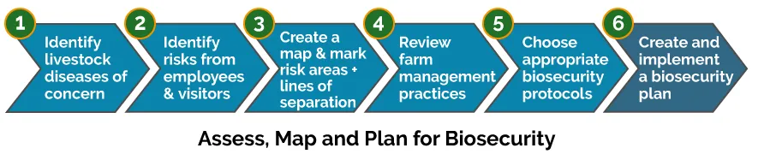
When developing your plan, start where you are – planning is a process. Determine procedures that fit the daily routine – overly complicated plans are rarely implemented. Implement the most important things first – do more as your farm grows. Develop protocols that everyone on the farm, including visitors, will need to follow if an outbreak occurs. Communicate your biosecurity protocols to workers and visitors and monitor compliance. Monitor your animals and crops daily and regularly document your animal and crop health. The list of questions below can help you assess what you need to do to develop your plan and identify protocols you might want to put in place.

BIOSECURITY - GENERAL
- Do you have designated visitor policies?
- Do you review these policies with visitors when they arrive?
- Do you require visitors to sign in and provide their addresses?
- Do you provide coveralls, plastic boot covers or boots for visitors?
- Do you regularly clean and disinfectant boots, tires, and equipment?
- If you borrow equipment, do you disinfect it before and after use?
- Do you have clearly marked handwashing stations stocked with soap, single use towels, wastewater collection devices and waste baskets?
- Do you have restroom facilities available?
- Are restrooms cleaned regularly and stocked with soap and single use towels?
- Do you use signage to remind visitors and farm/ranch staff to wash their hands?
- Do you have designated break/eating/smoking areas?

BIOSECURITY - ANIMALS
- Have you inventoried your animals?
- Can you identify your animals?
- Do you maintain animal health records?
- Do you have a sick animal isolation area away from other animals?
- Do you feed and treat your sick animals after healthy animal chores are completed?
- Do you change and disinfect clothes and footwear (or wear disposable boot covers) after working with sick animals?
- Do you have effective nutrition, vaccination, and parasite control programs?
- Do you quarantine new animals for at least 30 days before introducing them to your existing flock/herd?
- Do you store feed well away from sources of contamination such as fuel and chemicals?
- Do you protect feed from contamination by cat, bird, and other animal feces?
- Do you keep feed records?
- Do you use separate equipment for feed and waste handling?
- Do you locate watering areas away from potential sources of contamination such as roads and other areas accessible by the public?
- Do you have a plan for properly disposing of dead animals?
- Do you follow you animal disposal plans?
- Do you conduct routine inspections and maintenance on your fences and barns?
- Do you mitigate weed seed introduction from animal feed not produced on your farm?

BIOSECURITY - CROPS
- Do you conduct routine checks on crops to monitor for evidence of unusual disease or damage?
- Do you scout your field before harvest for bird and animal feces?
- Do you mark any feces and the splash zone area as non-harvestable?
- Do you take steps to exclude pets (dogs and cats) and other wildlife from your produce fields?
- Do you have handwashing policies for all workers and visitors entering and leaving your fields?
- Do you clean and sanitize harvest containers before each use?
- Do you clean and sanitize produce processing areas both indoors and outdoors?
- Do you store harvest and other containers off the ground and away from rodents and birds?
- If you use the same vehicles to transport produce and other farm inputs such as manure or composts, do you have protocols in place to ensure there is not cross-contamination?

If you have biosecurity questions, please contact Colette DePhelps, Community Food Systems Area Educator,
University of Idaho Extension cdephelps@uidaho.edu 208-885-4003 or your local extension office.

